STUDENT WORKBOOK

Section 1: Introduction

Descriptive Statistics
This workbook will help you become familiar with the content below, that you need to know for the descriptive statistics part of the specification.
1.3 Data recording, analysis and presentation | Learners should be able to demonstrate knowledge and understanding of the process and procedures involved in the collection, analysis and presentation of data. This will necessitate the ability to perform some calculations (please see Appendix 5d for examples of mathematical requirements).
Raw data | - design of raw data recording tables  - use of raw data recording tables  - standard and decimal form  - significant figures  - make estimations from data collected.
Levels and types of data | - nominal level data  - ordinal level data  - interval level data  - quantitative data  - qualitative data  - primary data  - secondary data.
Descriptive statistics | - measures of central tendency  - mode, median, mean  - measures of dispersion  - variance, range, standard deviation  - ratio  - percentages  - fractions  - frequency tables (tally chart)  - line graph  - pie charts  - bar charts  - histograms  - scatter diagram.

Section 4: Worksheet 2 – Measures of Dispersion
Measures of dispersion measure how spread out a set of data is and include the range, variance and standard deviation.
The RANGE is the difference between the lowest and highest values. It is calculated by subtracting the lowest score from the highest score in a data set.
For example:
3, 6, 8, 11, 14, 17, 18, 22, 23

23 is the highest score
3 is the lowest score
So the range is 20 (23-3)
Or
Number of seconds that it took Formula One drivers to complete a lap:

Lewis Hamilton – 75
Sebastian Vettel – 76
Nico Rosberg - 77
Felipe Massa – 77
Jenson Button –79
Pastor Maldonado – 133

133 – 75 + 1 = 59
The addition of +1 is a convention adopted to account for ‘measurement error’. +1 is only really necessary when dealing with data that are not 'absolutes' - i.e. not complete or whole figures, such as when recording reaction times and there may be error in stopping a timing device precisely on a second interval.
In the exam either method of calculating the range would be accepted.

The VARIANCE tells us about the spread of scores around the mean. So a small variance would imply that the scores are all similar and close to the mean. A large variance would indicate that the scores are at a larger distance from the mean.
The STANDARD DEVIATION is the square root of the variance, so it tells us the average amount a number differs from the mean.

Example
If we calculated the mean weather temperature throughout the summer in the UK, the mean may be 15 degrees. If we then calculated the standard deviation as being small, this would show that the temperature remained very consistent throughout the period. If, however, the standard deviation was very large, this would tell us that the weather varied greatly from very cold to very hot on some days.

Activity
Table 1: The mean number of aggressive acts displayed by children in two different nursery’s and the standard deviations for nursery one and nursery two.
 | Nursery one | Nursery Two
Mean | 4 | 3
Standard Deviation | 1.6 | 0.21

What do the standard deviations tell us about the results?

The Standard Deviation is a measure of how spreads out numbers are. Its symbol is σ (the Greek letter sigma) the formula is easy: It is the square root of the Variance.
http://www.mathsisfun.com/data/standard-deviation.html

Formulas
You need to learn a formula for the variance and for the standard deviation for exam. They do vary slightly depending on whether your data relates to a whole population or just a sample of the population. Either is acceptable for the exam.

Population Variance 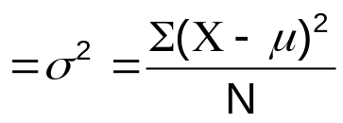

Sample Variance 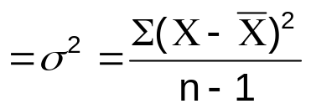

Population Standard Deviation 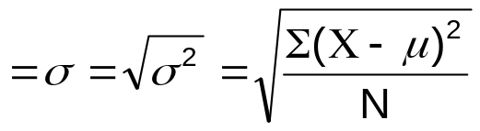

Sample Standard Deviation 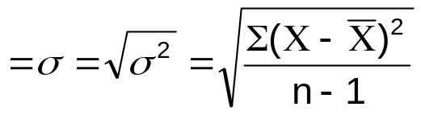

Activity: Calculating the Sample Variance and Standard Deviation
Step by step guide to calculating the variance and standard deviation.

Step 1: Calculate the mean 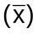 for your scores.
Step 2: Find the variance by subtracting the mean from each number in your sample. 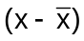
Step 3: Square the result of these calculations.
Step 4: Add the squared numbers together to find the sum of squares (sigma)
Step 5: Divide the sum of squares by 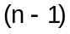 n = how many numbers you have in the sample
You now have the sample variance
Step 6: To find the standard deviation you just add this step - square root of the variance
Data | Difference from the Mean | Difference squared
10 | 2 | 4
10 | 2 | 4
8 | 0 | 0
8 | 0 | 0
8 | 0 | 0
4 | -4 | 16
Mean 48/6 = 8 |  | Total 24

Variance = 24 /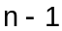(6-1) = 4.8
To find the standard deviation, find the square root of the variance.
SD = 2.19

Try it yourself – Now using the formulas above, calculate the population variance and the population standard deviation. The answers can be found over the page, so no peeping!

Population variance = 4, Population Standard Deviation = 2.

MCQ from A Level sample paper
What is a weakness of using a mode as a measure of central tendency?
- It can generate a number not in the data set
- It is easily affected by outliers
- It is not suitable for nominal data
- It relies on a score occurring more than once

Summary
Measure of Dispersion | Definition/how to calculate  (including formula) | When it is appropriate to use | When it is not appropriate to use
Range
Variance
Standard deviation

Section 5: Worksheets 3 – Levels of Measurement
The type of data analysis will depend on what level the measurement is. In psychology, there are 4 levels of measurement known as Nominal, Ordinal, Interval and Ratio data.
Level of Measurement | Used with | For example
Nominal | Frequencies or categories | Number of left handers – right handers, blue team – red team
Ordinal | Data that occurs in ranks or that can be placed in order from highest to lowest | Number of A, B and C grades achieved, Number of correctly recalled items from a list. Intervals are not fixed.
Interval | Units of equal size, but with no absolute zero point | Temperature (each degree is the same distance apart but there is no true zero point). Intervals are fixed.

Activity
Identify the level of measurement for the following data.
Data | Level of measurement
Age
Being happy / unhappy
Times of day on a 24 hour clock
Grand national order of finishers

Data analysis and levels of measurement
Data | Measure of central tendency / Dispersion
Nominal | Mode
Ordinal | Median  (Mode can also be used)
Interval / Ratio | Mean  Median and Mode can also be used)  Standard deviation

Measures of Central Tendency – Summary Table
Complete the table to check your understanding.
Measure | What is it? | When should it be used? | Advantages | Disadvantages

Mean

Median

Mode

Learner Resource Measures of Dispersion
Complete the table to check your understanding.
Measure | What is it? | When should it be used? | Advantages | Disadvantages

Range

Variance

Standard deviation

Section 6: Worksheet 4 – Charts and Graphs
Graphs, charts and tables are all used to describe data and make it easier for the data to be understood.
There are a number of graphs and charts that you need to be able to draw and interpret, they include:
- Tally chart (frequency table)
- Line graph
- Pie chart
- Bar chart
- Histogram
- Scatter diagram

Drawing graphs and tables

Frequency tables (tally charts)
Tally marks are used for counting things. These are used in content analyses and observations. They record the number of times something is seen.
Observation of baby… | Tally | Total
Feeding | llll | 4
Crying | ll | 2
Sleeping | llll ll | 7

Bar charts can be used to represent the data from frequency tables, mean scores or the totals. They are used with nominal or ordinal levels of measurement. The bars are kept separate from each other, for example using the data from the frequency table:
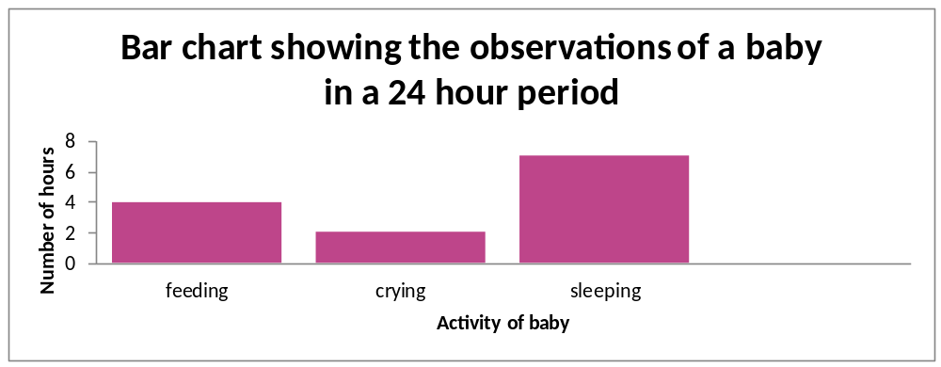
Histograms are used with interval or ratio data. There are no gaps between the columns to represent a continuous data set.
For example:
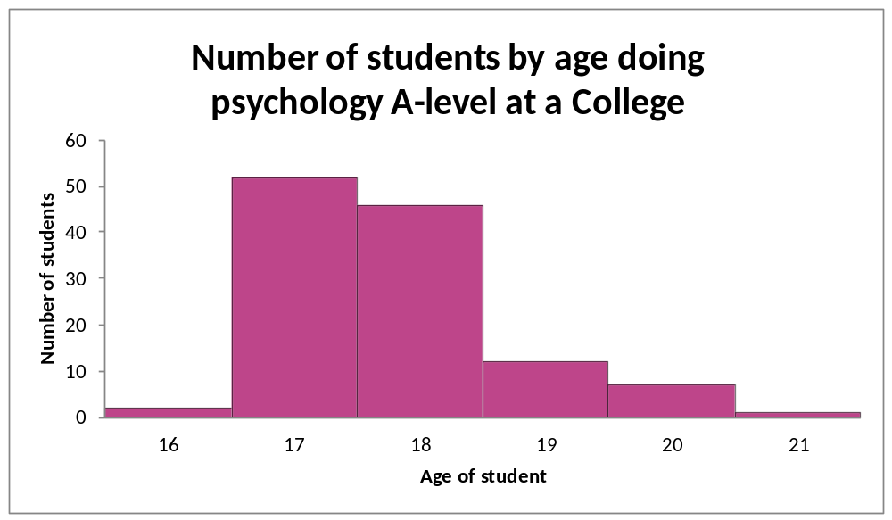
Line graphs can be used as an alternative to histograms. These are used to show the results from two or more conditions at the same time.
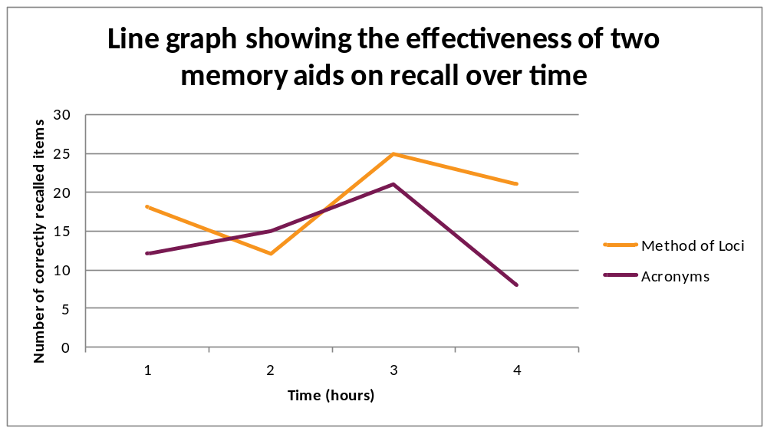For example:

Pie charts are used when we have percentages. Each segment represents a percentage of the total.
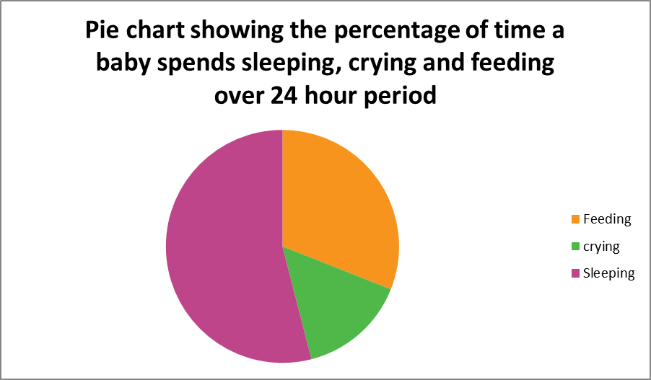
Scatter diagrams are used with correlations where the relationship of two variables is summarised. They illustrate the direction of the relationship (positive, negative or zero correlation) and can indicate the potential strength of the relationship.
For example, this scatter graph shows a positive correlation between ice cream sales and weather.
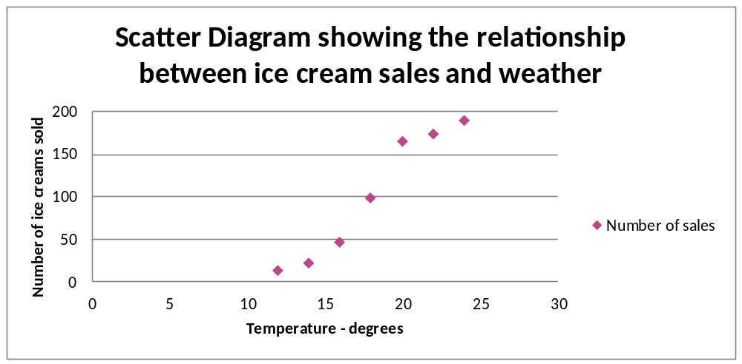

Activity
A teacher analysed the performance of her students who had sat A level Psychology, by the grade they achieved.
Plot the following data onto a bar chart. Remember to give the graph a title, label both axes and use a ruler!
Grade | Number of students
A | 3
B | 12
C | 5
D | 2
E | 3
U | 0

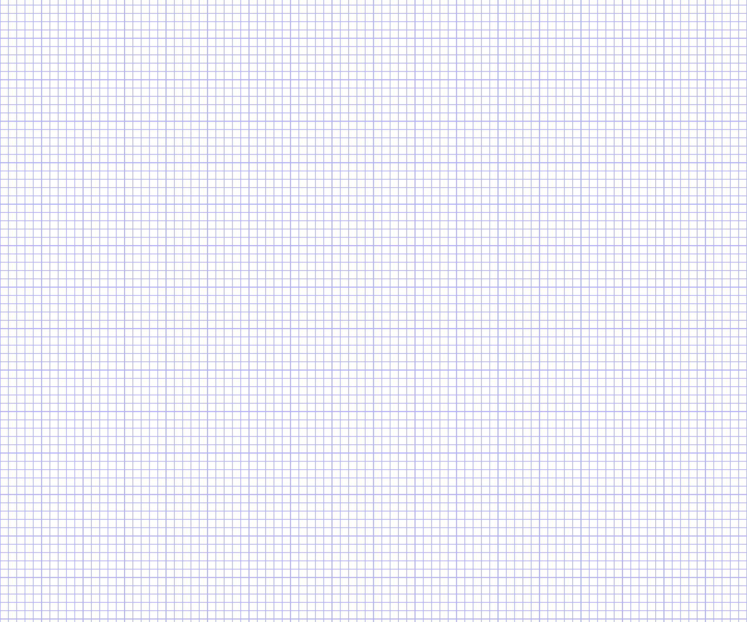
http://www.mathsisfun.com/data/data-graph.php enables graphs to be constructed on the computer.

Histograms
Bar charts should be used with categorical data, however with continuous data such as weight, height and temperature, a histogram should be used. Histograms unlike bar charts also have no gaps between the bars.
You may be interested to know how much time students spend on their homework. As an activity, you could ask other members of your class to reveal this for their last homework (although there may be some social desirability bias!) Hopefully the majority of your class spend around 100 minutes on their psychology homework!
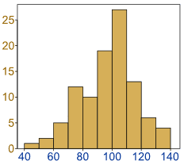
Extension task: Come up with your own examples where histograms could be used.

Interpreting graphs
When we interpret the graph or chart, we are just making sense of the information.
The first and crucial step in interpreting graphs is to make sure that you read all of the parts, including the title, axis and the direction the results are moving in.
The title tells us what the graph is about.
The axes tell us what the variables are.

Exercise
Write a statement describing what the results in the below bar chart show. Make reference to the title, both axes and the direction of the results in your answer.

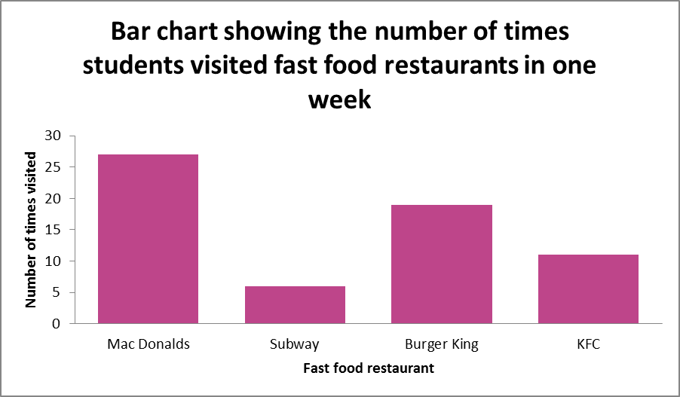

Identify the type of graph and suggest when the graph might be best used.


