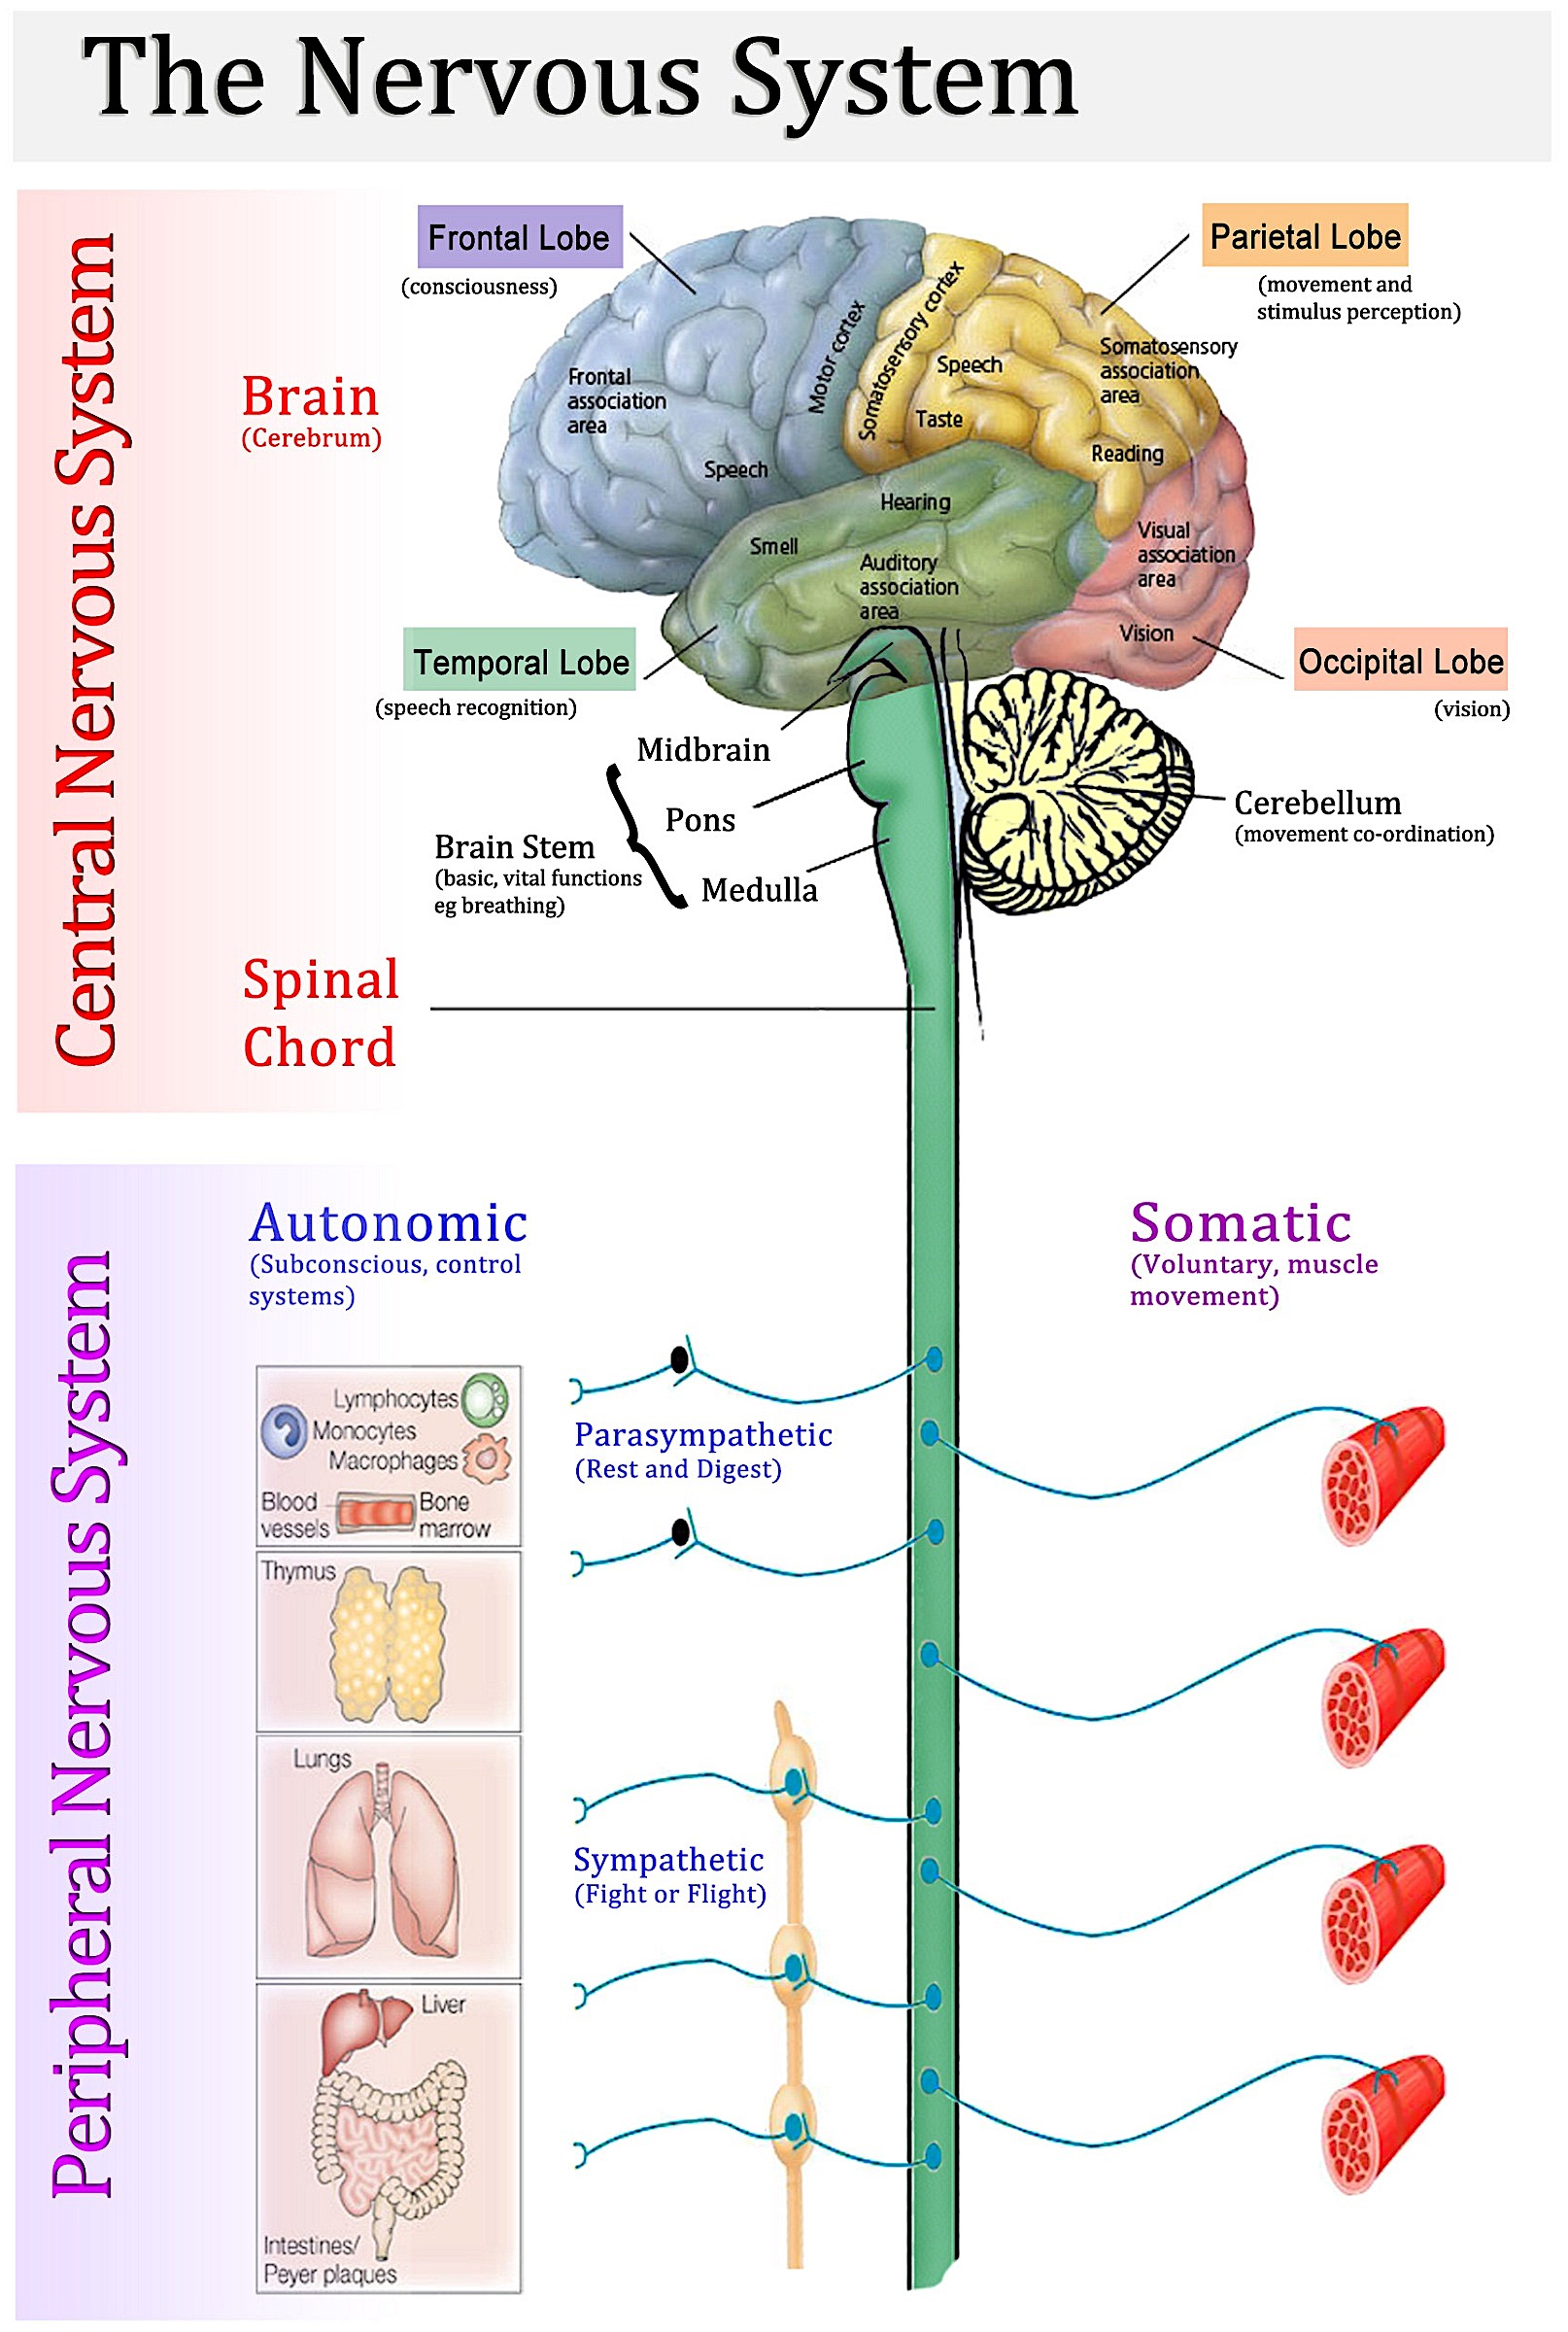

**Include examples below**

**Include examples below**