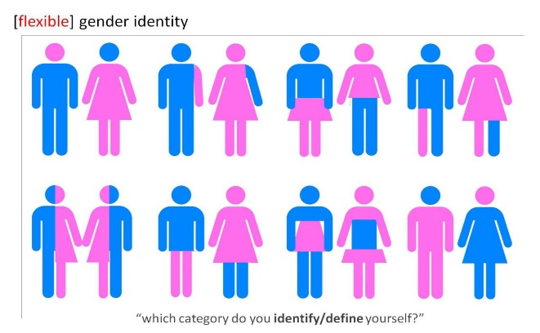The biological theory suggests that …………

[](http://www.google.co.uk/imgres?imgurl=http://dir.coolclips.com/Healthcare/Medical_Symbols/Conception/sperm_fertilizing_egg_CoolClips_vc017616.jpg&imgrefurl=http://dir.coolclips.com/Healthcare/Medical_Symbols/Conception/sperm_fertilizing_egg_vc017616.html&h=366&w=375&tbnid=DVqkyEeD1uQ59M:&zoom=1&q=sperm+and+egg+conception&docid=gPbFOi3X_y2WNM&hl=en&ei=HKjAVLz9NoPqUtSrgdAJ&tbm=isch&ved=0CCoQMygJMAk)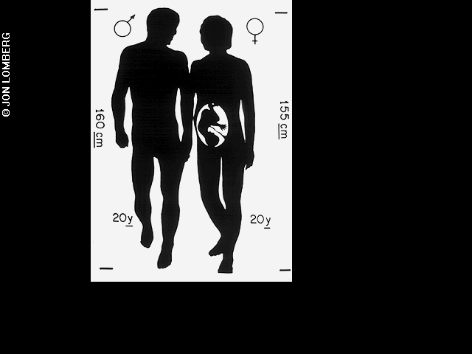

[](http://www.google.co.uk/url?sa=i&rct=j&q=chromosomes+xx&source=images&cd=&cad=rja&uact=8&ved=0CAcQjRw&url=http://www.shutterstock.com/pic-41183305/stock-photo-xx-chromosome.html&ei=pvy_VMGUBMXoUpHegNgB&psig=AFQjCNH9HhwjbJwspfKr8PwbX-7h8KkFAw&ust=1421954595906063)[](http://www.google.co.uk/url?sa=i&rct=j&q=chromosomes+xy&source=images&cd=&cad=rja&uact=8&ved=0CAcQjRw&url=http://www.vinvin.net/?attachment_id=2500&ei=7Py_VMPDMoarU83DgrAE&psig=AFQjCNEeYW4jFpKtDShsQQ3XsTZjoYoSAQ&ust=1421954663008345)

[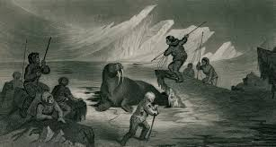](http://www.google.co.uk/imgres?imgurl=http://upload.wikimedia.org/wikipedia/commons/5/59/Walrus_hunting.jpg&imgrefurl=http://en.wikipedia.org/wiki/Culture_of_Greenland&h=1442&w=2690&tbnid=hdMW8r1knx2wWM:&zoom=1&q=hunting&docid=AfNViJfo48AhUM&hl=en&ei=eQDAVIyBEsPlUpqdg5gH&tbm=isch&ved=0CBgQMygQMBA4ZA)[](http://www.google.co.uk/imgres?imgurl=http://images.pcmac.org//images/Users/housej@gcschools.net//space.jpg&imgrefurl=http://ghs.gcschools.net/?PageName='OrganizationPage'&OrganizationID='14653'&h=275&w=300&tbnid=hK_tscE7nbE0lM:&zoom=1&q=visual+spatial+skills&docid=n-pJbvVDq7WJcM&hl=en&ei=u_6_VIjiD4ryUv-7gYgO&tbm=isch&ved=0CF4QMygvMC8)[](http://www.google.co.uk/imgres?imgurl=http://bulletin.swarthmore.edu/bulletin-issue-archive/wp-content/uploads/2011/July/IML_1944_thompson_webb_infant.jpg&imgrefurl=http://bulletin.swarthmore.edu/bulletin-issue-archive/index.html?p=701.html&h=622&w=468&tbnid=Ojsa7-EK9GU0uM:&zoom=1&q=caring+mom&docid=O2DErxmqKsbNoM&hl=en&ei=_v-_VPGxNpb1areegpgK&tbm=isch&ved=0CCYQMygCMAI)[](http://www.google.co.uk/imgres?imgurl=http://www.utm.my/insteg/wp-content/blogs.dir/270/files/2013/05/comunication-skill.jpg&imgrefurl=http://www.utm.my/insteg/blog/2013/05/23/communication-skills/&h=1302&w=1600&tbnid=EgVBJiZIIt9WtM:&zoom=1&q=communication+skills&docid=Cr2rdkJLpydFpM&hl=en&ei=e_-_VIXuL4usUePKguAM&tbm=isch&ved=0CC8QMygOMA4)[](http://www.google.co.uk/url?sa=i&rct=j&q=caring&source=images&cd=&cad=rja&uact=8&ved=0CAcQjRw&url=http://www.caring-people.co.uk/looking-for-staff/&ei=RLvAVOfGEoq0Ue3og9AC&psig=AFQjCNF46vvC-S9tifgAUGW-3XdbpE18Pw&ust=1422003349363340)[](http://www.google.co.uk/imgres?imgurl=http://nspt4kids.com/wp-content/uploads/2011/05/aggressive-boy.jpg&imgrefurl=http://nspt4kids.com/parenting/hitting-biting-pushing-and-shoving-how-to-handle-your-childs-aggressive-behavior/&h=282&w=425&tbnid=2XjmKwM6dLxJ1M:&zoom=1&q=aggressive&docid=XznrSPqYzwuA4M&hl=en&ei=GbrAVLLpFoL8Us2bgvAM&tbm=isch&ved=0CHoQMyhLMEs)[](http://www.google.co.uk/imgres?imgurl=http://www.aloewellnessdc.com/wp-content/uploads/2014/10/hormones.jpg&imgrefurl=http://www.aloewellnessdc.com/2014/10/16/hormone-testing-for-wellness/&h=306&w=400&tbnid=gr3hxXPrFOUFdM:&zoom=1&q=hormones&docid=QWj0gbVYcpJzIM&hl=en&ei=Fv6_VPbvNojOaPTGgKgO&tbm=isch&ved=0CCMQMygCMAI)[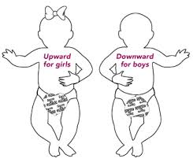](http://www.google.co.uk/url?sa=i&rct=j&q=gonads&source=images&cd=&cad=rja&uact=8&ved=0CAcQjRw&url=http://www.natus.com/index.cfm?page=products_1&crid=197&ei=4v2_VIV5if1Ssc2A8AQ&psig=AFQjCNFpMx9yzWsuQx50VIxIQ0P3moCjUQ&ust=1421954884307652)